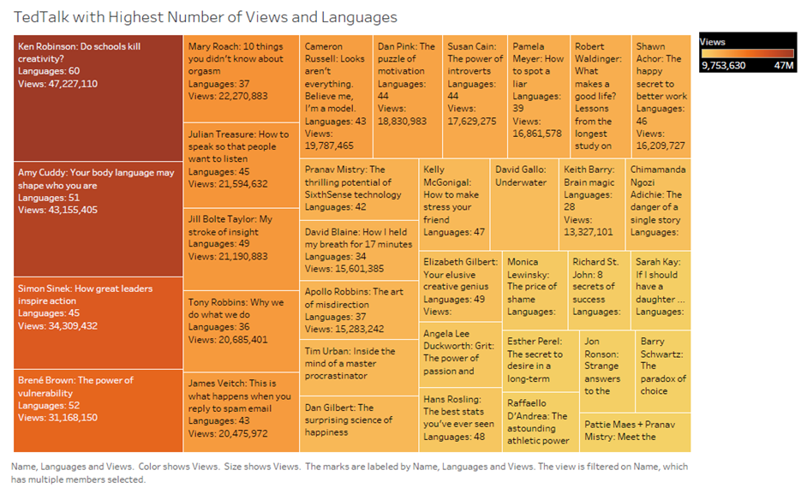

The above Tree Map visualization created in Tableau shows the most popular Ted Talk based on Views and Languages. In this visualization, there are three variables being mapped, two continuous variables and the third name of the TED Talk. The continuous variables are the Views and the Languages. These variables were first mapped using area of the box where the proportion of the area was based on the number of Views and the number of Languages. The largest area box showed the TED Talk with the both the highest number of Views and Languages. The next highest area shows the next highest TED Talk and so on. The Tree Map was then refined by adding orange to gold sequential color palette. The highest Viewed and Languages TED Talks was represented by deep orange color and the lowest was represented by the light gold color. The Tree Map was further refined to show the name of the TED Talk with speaker name and actual count labels for both the Views and the Languages for each of the Ted Talks. Furthermore, interactivity was also added into this Tree Map to allow the user to change the number of top talks by the Views and the Languages. All three combination of visual representation along with interactivity made the Tree Map visualization appropriate.

Based on the Tree Map, the most Viewed and Language talk of all time was the, “Ken Robinson: Does School Kill Creativity?” This talk had over 47 million views and was translated into 60 languages. Followed by the, “Amy Cuddy: Your body language may shape who you are.” This talk had around 43 million views and was translated into 51 languages. And so on. From the Tree Map, we also see that the highest number of the Views did not mean higher number of Languages the TED Talk was converted.